

Semester Two Examination, 2020

Question/Answer booklet

MATHEMATICS METHODS
UNIT 1 AND 2

Section One:

Calculator-free

Name: __________________SOLUTIONS____________________________

Teacher’s Name:_______________________________________________

Time allowed for this section
Reading time before commencing work: five minutes
Working time: fifty minutes

Materials required/recommended for this section
To be provided by the supervisor
This Question/Answer booklet
Formula sheet

To be provided by the candidate
Standard items: pens (blue/black preferred), pencils (including coloured), sharpener, correction fluid/tape, eraser, ruler, highlighters

Special items: nil

Important note to candidates
No other items may be taken into the examination room. It is your responsibility to ensure that you do not have any unauthorised material. If you have any unauthorised material with you, hand it to the supervisor before reading any further.
Question | Marks | Max | Question | Marks | Max
1 |  | 7 | 6 |  | 3
2 |  | 4 | 7 |  | 6
3 |  | 4 | 8 |  | 6
4 |  | 6 | 9 |  | 4
5 |  | 6

Structure of this paper

Section | Number of questions available | Number of questions to be answered | Working time (minutes) | Marks available | Percentage of examination
Section One:  Calculator-free | 9 | 9 | 50 | 50 | 34
Section Two:  Calculator-assumed | 14 | 14 | 100 | 85 | 66
 |  |  |  | Total | 100

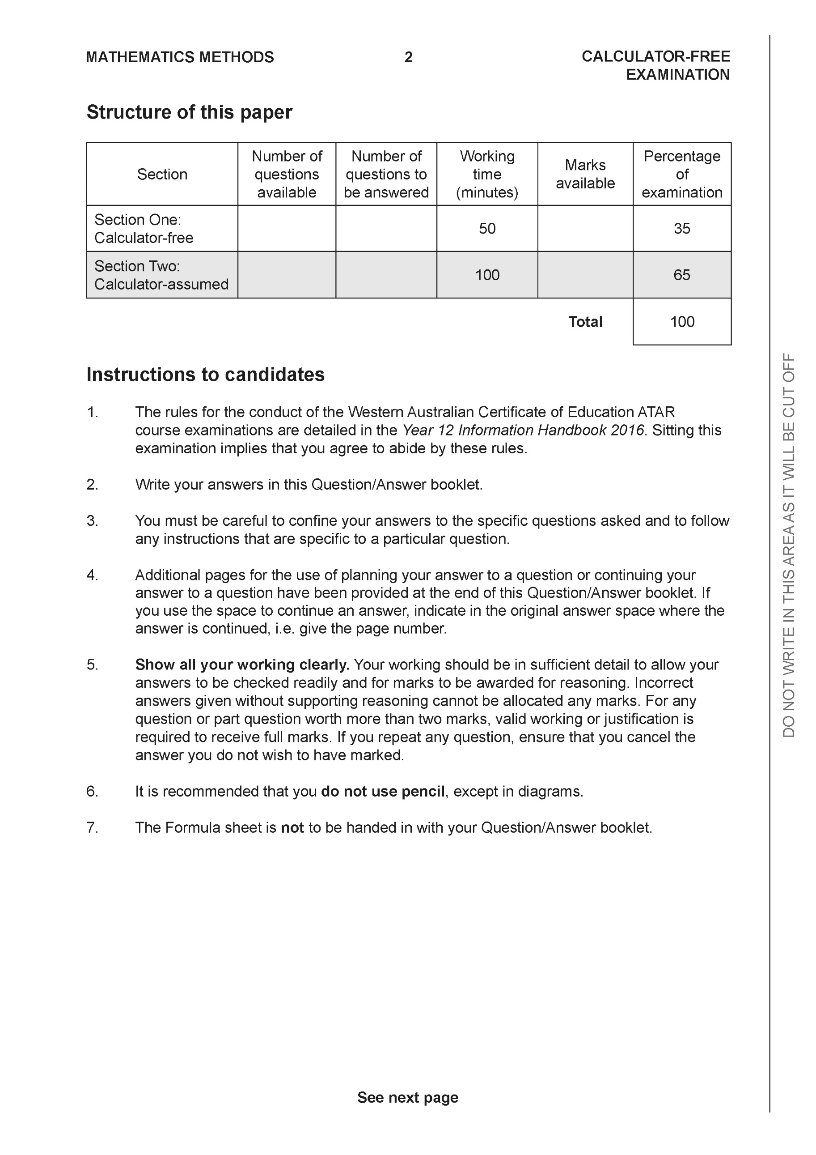

Section One: Calculator-free (44 Marks)

This section has nine (9) questions. Answer all questions. Write your answers in the spaces provided.

Spare pages are included at the end of this booklet. They can be used for planning your responses and/or as additional space if required to continue an answer.
● Planning: If you use the spare pages for planning, indicate this clearly at the top of the page.
● Continuing an answer: If you need to use the space to continue an answer, indicate in the original answer space where the answer is continued, i.e. give the page number. Fill in the number of the question that you are continuing to answer at the top of the page.

Working time: 50 minutes.

Question 1 {2.2.1, 2.2.7} (7 marks)
(a) The second term of a geometric sequence is 15 and the fourth term is 135.

Determine the sum of the first 4 terms of the sequence. (4 marks)

(1 mark) obtains an equation for one variable only
(1 mark) solves one value of r
(1 mark) solves for two values of a
(1 mark) solves for two sums

(b) Determine the sum of the first 100 integers
i.e 1+2+3+ ……+99+100. (3 marks)

(1 mark) recognizes arithmetic
(1 mark) uses sum formula
(1 mark) evaluates sum

Question 2 {2.2.5, 2.1.3} ( 4 marks)

The fifth term and the ninth term of an arithmetic sequence are 26 and 42 respectively.
Determine the twenty-first term.

(1 mark) Sets up two equations for parameters
(1 mark) solves for difference
(1 mark) solves for first term
(1 mark) solves for required term

Question 3 {1.1.24} ( 4 marks)

Determine the natural domain and corresponding range for the following:

functions | Domain | Range
 | R | R
 | R

(1 mark) two correct domains
(1 mark) four correct domains
(1 mark) two correct ranges
(1 mark) four correct ranges

Question 4 {1.2.8, 1.2.10, 1.2.12, 1.2.13} (3, 3 = 6 marks)

- Solve the following trigonometric equation

(1 mark) solves for one angle for 3x
(1 mark) solves for two angles for x
(1 mark) solves for at least four angles for x

b) Sketch the graph of the following equation


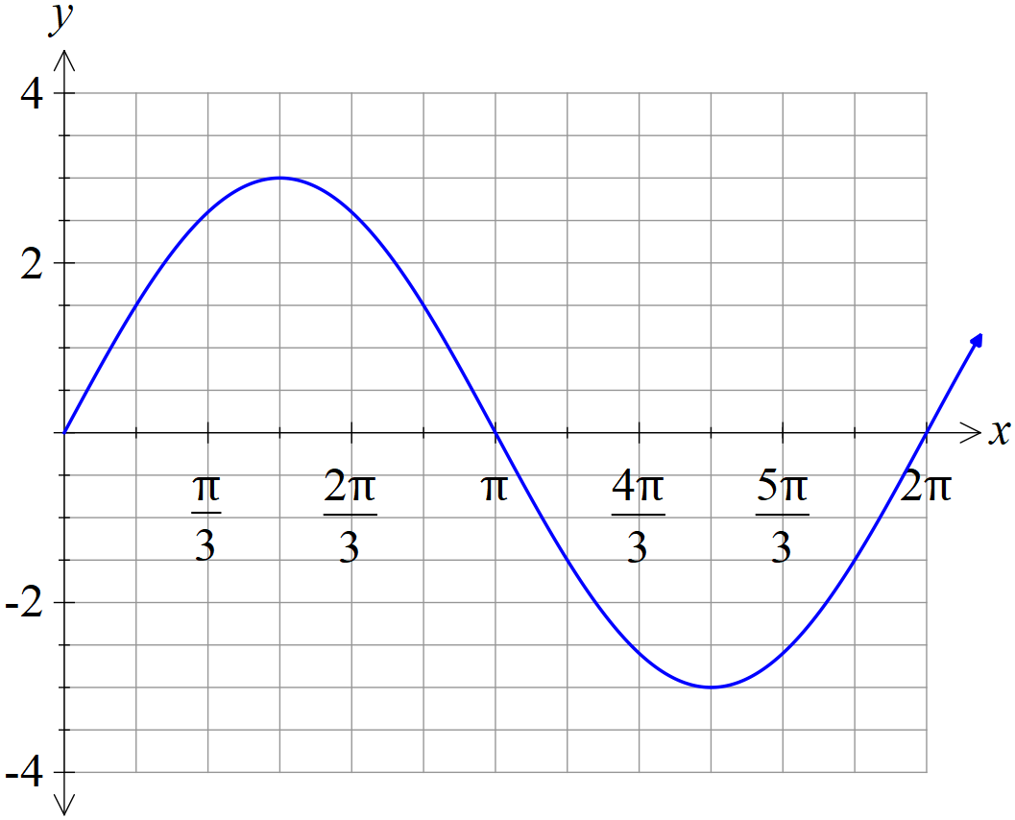

(1 mark) amplitude
(1 mark) all x intercepts
(1 mark) shape AND y intercept

Question 5 {2.1.2, 2.1.7} (3, 3 = 6 marks)

On the axes provided, sketch each of the following exponential functions. Remember to label any intercepts or asymptotes.

(a) $y=2^{x}+3$

(b) $y=0.5×4^{x}-1$

Question 6 {1.2.16} (3 marks)

Solve for x:

Question 7 {1.1.17} (6 marks)

Show that $x+1$ is a factor $x^{3}-x^{2}+3x+5$ of and hence find the other factor

Question 8 {1.3.1, 1.3.5} (2, 2 = 4 marks)

The first four rows of Pascal’s triangle are shown below.

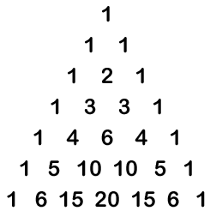

Simplify all answers in this question.

- Expand the expression ${\left(x-2\right)}^{5}$.

- Find the third term of the expansion of ${\left(2x-3y\right)}^{4}$

substitutes correct terms
correct answer

Question 9 {2.3.15, 2.3.9} (2, 2 = 4 marks)

- Find the derivative of the function $f\left(x\right)=\frac{4}{x^{2}}+2x$ . Express your answer with a positive indices.

correct derivative
expresses as a positive indice

- Find the equation of the curve if the gradient at any point of the curve is given by
$\frac{dy}{dx}=1-2x$ and the curve passes through the point (1,2).

correct anti-derivative with c.
Correct equation.

END OF SECTION 1
Additional working space
Question number:

Additional working space
Question number:

